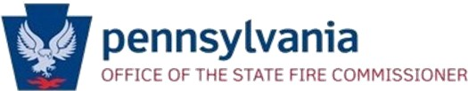

PA Fire Advisory Board Meeting
May 16, 2024
1:00pm – 3:00pm

Agenda

Call to Order/Roll Call
Opening Remarks
Minutes of the previous meeting (Action Item)
Legislative Overview – Wes Majors
Loan Program Update
Reaccreditation Update from the Fire Academy – Harvey Boyer
Update from Relief Association Reform Sub-Committee – Steve Bair
Cancer allowable expense – Isaac Gaylord
Update from Best Practices Subcommittee
Update from State Memorial Subcommittee
Old Business
New Business
Other Business / Public Comment / Closing Remarks
Next Meeting: September 19, 2024
Adjournment

